/100 points (Pass with 70 points)
2025.10..21
Answer Key Written Examination For
2rd Grade Yabusame Skills License

NAME

１. Knowledge about Safety and Rules

Q1）The maximum draw weight for novice and intermediate competitors is（ 8 ）Kg.
【2 points each /2 points】

Q2）The maximum draw weight for advanced competitors is（ 10 ）Kg.
【2 points each /2 points】

Q3）What are the three reasons there are set draw weight limits for competition?
【4 points each /12 points】

- To understand and keep the correct shooting form (Kata).
- To keep correct riding form. __
- To maintain fairness of the competition. ____

Q4）Describe the arrowhead (Kabura) used in Yabusame competition.
【4 points each /4 points】

A wooden sphere with a diameter of 3 (three) cm or more

Q5）Explain why long reins are not suitable for Yabusame.
【4 points each /4 points】

With long reins, it is not easy for riders to take the reins promptly to control movements of the horse.

Q6）What is the difference between arrows used by novice/intermediate competitors, versus arrows used by advanced, professional and team competitors?
【2 points each /2 points】

Novice and intermediate use 2 feathered arrows and advanced, professional and team competitors use three-feathered arrows.

２. Horse Riding Aids

Q1）Choose the most suitable word/words from the list below to fill the blanks (1) to (4) in the sentences.
【2 points each /8 points】
In traditional Japanese riding, the rider gives aids to the horse with their reins to ask the horse to move forward. This technique of communicating with the horse is called “（① shakuru ）” or “aoru.” The rider moves their hands （② up and down ） to tell the horse move forward. This movement produces contact with the snaffle and sides of the neck. The rein aids are used to control turning and steering, as well as （③ Ou (signaling the horse to move forward) .）In traditional Japanese riding, you use three types of aids to communicate and control the horse. The aids include rein aids, （④ whip ）and vocal aids.

・Kiou ・up and down ・Ou (signaling the horse to move forward) ・whip
・leg aids ・shakuru ・right and left ・encouragement

Q2）What is the best timing for a rider to let go of their reins after starting towards the 1st target?
【4 points each /4 points】

When the horse is running straight down the track at a stable speed with consistent rhythm.

Q3）Explain the reason/reasons why your answer to Q2 is the best timing.
【4 points each /4 points】

Because the rein aids are essential for the rider to tell the horse to run along the intended course and proper speed.
Because it is dangerous for a rider without reins to let the horse run as it pleases.

３. KASAGAKEKI
“Begin by looking at the target and raise the bow calmly. Draw the bow completely while making the horse run. Release the bowstring when it reaches ( 1. ) and release the arrow with spirit. Upon releasing, continue to twist your right inward to make the palm face outward.”

※Quoted from “Kasagakeki” included in “Gunsho Ruijyu.”

Q1）Read the above description quoted from “KASAGAKEKI” and write the suitable word/words to fill the blank (1) to complete the sentence.
【3 points each /3 points】

Ushiro no Kura (the rear part of the saddle)

Q2）What is the term for the movement described in the underlined sentence above; “twist your right hand inward to make the palm facing outward.”
【3 points each /3 points】

Uchikiri

４．Horse and Equipment Parts

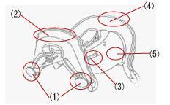
Q）Name the parts of the saddle and the parts of the horse shown in the illustration and photo below.

（1）Shiode 【3 points each /3 points】
（2）Maewa 【3 points each /3 points】
（3）Chikaragawa Toshiana【3 points each /3 points
（4）Shizuwa 【3 points each /3 points】
（5） Igi 【3 points each /3 points】

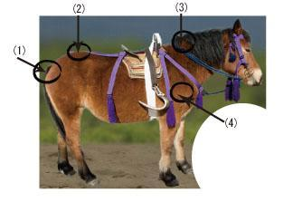
（1）Ozutsu 【3 points each /3 points】
（2）Sanzu 【3 points each /3 points】
（3）Torikami 【3 points each /3 points】
（4）Shoudounoshishi 【3 points each /3 points】

６．Riding Posture

See the photo below and answer the following questions.
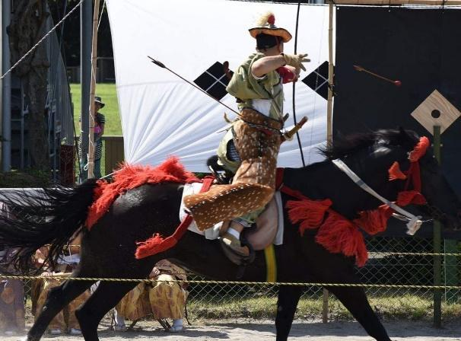

Q1）Is this riding posture in the photo above safe or dangerous? Explain why.
【4 points each /4 points】
Dangerous.
Because the rider is out of balance cannot react to sudden movements of the horse when their toes are behind the girth and body is too upright.

Q2）If the riding posture in the above photo is dangerous, how can this riding posture be corrected?
【4 points each /4 points】

- By pushing Abumi (stirrups) forward and placing them around the shoulder of the horse (shoudounoshishi).
- By pushing the rider’s hips back over the cantle and making his/her belly face downward to stabilize the riding posture.

７．Archery Techniques on the Horseback (Basic Posture and Application Posture)

Q1）What is the name for the basic posture of an archer‘s upper body on the horseback? Chudou
【3 points each /3 points】

Q2）What is the name for the posture of an archer’s upper body where the archer leans towards the target. This posture is used for targets at close range or a low position.
Kakarudou
【3 points each /3 points】

Q3）What is the name for the posture of an archer’s upper body which is used for shooting the arrows on horseback, a rocking ship, or when they wear the armor.
Kagamudou
【3 points each /3 points】
８．Subase (Trial Run)

Q1）What is the purpose of Subase?
【3 points each /3 points】
To let riders and horses get accustomed to the course and the atmosphere of the event.
To establish master-servant relationship between the rider and the horse.
To teach the horse how to synchronize with the rider.

Q2）What is the correct way to hold the reins during Subase?
【4 points each /4 points】

The rider holds their reins in such a way to make it into an isosceles triangle shape so that the horse may lift up its head slightly.

